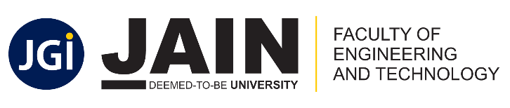
CO-PO Attainment
Machine Learning
18CS62
(Jan – May 2021)


CO-PO Attainment
Machine Learning
18CS62
(Jan – May 2022)


CO-PO Attainment
Machine Learning
18CS62
(Jan – May 2022)

